SQL Practice exercises

Goal: Put into practice what you have learned so far in the SQL lectures (basic queries and more advanced queries)

There are 15 questions to solve with queries that are roughly of increasing difficulty:

* Level 1: Stretching
* Level 2: Pouring some spices
* Level 3: Why so serious?

**The document to submit should be either a doc file or a pdf file with the answers to each question:**

1. **The query you ran**
2. **The result you got**

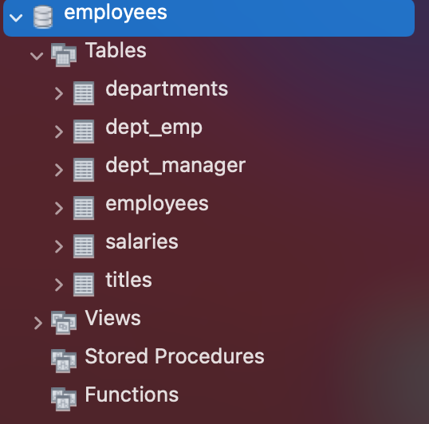

# Database schema

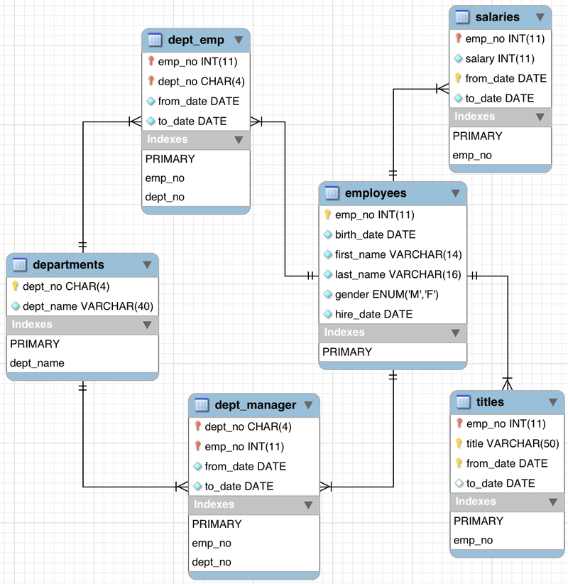

# 

# 

# Stretching

**Q1 - How many unique employees are there?**

USE employees;

SELECT COUNT(emp_no) AS emp_count

FROM employees;

**300024**

**Q2 - How many males and females employees are there? Order the counts in descending order.**

SELECT gender, COUNT(gender) AS emp_count

FROM employees

GROUP BY gender;

Male - **179973**

Female - **120051**

**Q3 - Display the year and total hires for the year with the most hires**

SELECT YEAR(hire_date), COUNT(emp_no)

FROM employees

GROUP BY YEAR(hire_date)

ORDER BY COUNT(emp_no) DESC

LIMIT 1;

1986 – **36150**

Q4 - What is the name of the department with the most employees

SELECT dept.dept_name, COUNT(dept_emp.emp_no)

FROM dept_emp

JOIN departments AS dept

ON dept_emp.dept_no = dept.dept_no

GROUP BY dept_emp.dept_no

ORDER BY COUNT(dept_emp.emp_no) DESC

LIMIT 1;

**Development** - 85707

Q5 - How many employees were born on November 12? What's the percentage out of all the employees?

SELECT COUNT(emp_no) AS EMP_COUNT, COUNT(emp_no) / (SELECT COUNT(emp_no) FROM employees) AS EMP_PREC

FROM employees

WHERE MONTH(birth_date) = 11 AND DAY(birth_date) = 12;

EMP_COUNT – **800**; EMP_PREC – **0.0027**;

Q6 - What are the 3 most common employee titles (display the employee titles and the number of times they occur)

SELECT title, COUNT(emp_no)

FROM titles

GROUP BY title

ORDER BY COUNT(emp_no) DESC

LIMIT 3;

**Engineer – 115003**

**Staff – 107391**

**Senior Engineer – 97750**

Q7 - Find the avg salary for each department (department name). Round to the nearest integer and order by avg salary from the highest to the lowest.

SELECT dept.dept_name, ROUND(AVG(sal.salary),0)

FROM salaries as sal

JOIN dept_emp

ON sal.emp_no = dept_emp.emp_no

JOIN departments AS dept

ON dept_emp.dept_no = dept.dept_no

GROUP BY dept.dept_no

ORDER BY AVG(sal.salary) DESC;

|  |  |
| --- | --- |
| Sales | 80668 |
| Marketing | 71913 |
| Finance | 70489 |
| Research | 59665 |
| Production | 59605 |
| Development | 59479 |
| Customer Service | 58770 |
| Quality Management | 57251 |
| Human Resources | 55575 |

# Pouring some spices

Q8 - Find the average salary by employee title. Round to 2 decimals and order by descending order

SELECT ttl.title, ROUND(AVG(sal.salary),2)

FROM salaries AS sal

JOIN titles AS ttl

ON sal.emp_no = ttl.emp_no

GROUP BY ttl.title

ORDER BY AVG(sal.salary) DESC;

|  |  |
| --- | --- |
| Senior Staff | 70470.84 |
| Staff | 69309.10 |
| Manager | 66924.27 |
| Senior Engineer | 60543.22 |
| Engineer | 59508.04 |
| Assistant Engineer | 59304.99 |
| Technique Leader | 59294.37 |

Q9 - Find the number of employees who have worked in at least 2 departments

SELECT COUNT(emp_no) - COUNT(DISTINCT emp_no)

FROM dept_emp;

**31579**

Q10 - Get the distribution of the year of the hire dates. (hint: you should end up with a number of employees per year of hiring date)

SELECT COUNT(emp_no), YEAR(hire_date)

FROM employees

GROUP BY YEAR(hire_date)

ORDER BY YEAR(hire_date);

|  |  |
| --- | --- |
| 35316 | 1985 |
| 36150 | 1986 |
| 33501 | 1987 |
| 31436 | 1988 |
| 28394 | 1989 |
| 25610 | 1990 |
| 22568 | 1991 |
| 20402 | 1992 |
| 17772 | 1993 |
| 14835 | 1994 |
| 12115 | 1995 |
| 9574 | 1996 |
| 6669 | 1997 |
| 4155 | 1998 |
| 1514 | 1999 |
| 13 | 2000 |

Do you notice any pattern? Assuming there is no missing data, is the company hiring more or less as time goes by?

Less…

Q11 - Display the first name, last name, and salary of the highest paid employee

SELECT sal.salary, emp.first_name, emp.last_name

FROM salaries AS sal

JOIN employees AS emp

ON sal.emp_no = emp.emp_no

ORDER BY sal.salary DESC

LIMIT 1;

|  |  |  |
| --- | --- | --- |
| **158220** | **Tokuyasu** | **Pesch** |

Q12 - Display the first name, last name, and salary of the THIRD highest paid employee

SELECT sal.salary, emp.first_name, emp.last_name

FROM salaries AS sal

JOIN employees AS emp

ON sal.emp_no = emp.emp_no

ORDER BY sal.salary DESC

LIMIT 1 OFFSET 2;

|  |  |  |
| --- | --- | --- |
| **156286** | **Honesty** | **Mukaidono** |

# Why so serious?

Q13 - Display each department name and the age of the youngest employee at hire date

SELECT MIN(ROUND((DATEDIFF(emp.hire_date, emp.birth_date) / 365.25), 2)) AS emp_age_at_hire, dept.dept_name

FROM employees AS emp

JOIN dept_emp

ON emp.emp_no = dept_emp.emp_no

JOIN departments AS dept

ON dept_emp.dept_no = dept.dept_no

GROUP BY dept.dept_name

ORDER BY emp_age_at_hire ASC;

|  |  |
| --- | --- |
| 20.03 | Development |
| 20.03 | Research |
| 20.06 | Customer Service |
| 20.06 | Marketing |
| 20.07 | Production |
| 20.09 | Finance |
| 20.12 | Human Resources |
| 20.12 | Sales |
| 20.16 | Quality Management |

Q14 - What's the range of age the employees would be today (calculate their age whole years)

SELECT MIN(FLOOR((DATEDIFF(CURRENT_DATE(), birth_date) / 365.25))) AS youngest_emp_today,

MAX(FLOOR((DATEDIFF(CURRENT_DATE(), birth_date) / 365.25))) AS oldest_emp_today

FROM employees;

|  |  |
| --- | --- |
| 56 | 69 |

Q15 - How many employees were born on the same date (day-month-year) in 1955.

NB: Change the according to preferences parameters if your query fails because of a timeout

Option 1 (allows multiple birth dates, if there is more than 1 employee born in it)

SELECT SUM(same_date_emp_count_1955) AS sum_ same_date_emp_counts_1955

FROM (

SELECT COUNT(DISTINCT emp_no) AS same_date_emp_count_1955

FROM employees

WHERE YEAR(birth_date) = 1955

GROUP BY birth_date

) AS table_ same_date_emp_counts_1955;

23104

Option 2 (shows only the birth date with max number of employees born in it

SELECT COUNT(birth_date), birth_date

FROM employees

WHERE YEAR(birth_date) = 1955

GROUP BY birth_date

ORDER BY COUNT(birth_date) DESC

LIMIT 1;

|  |  |
| --- | --- |
| 90 | 1955-03-03 |